Multiple-choice section – choose the correct answer

|  |  |  |  |  |  |  |  |  |  |  |
| --- | --- | --- | --- | --- | --- | --- | --- | --- | --- | --- |
| Question | 1 | 2 | 3 | 4 | 5 | 6 | 7 | 8 | 9 | 10 |
| Answer | A | B | D | C | D | D | D | C | B | C |

Question 1 [6.1]

A

For angle φ: Opposite side: a, Hypotenuse: c, adjacent side: b

For angle θ: Opposite side: b, Hypotenuse: c, adjacent side: a



Question 2 [6.1]

B

sin(θ) = 0.8

θ = 53.13°

sin(2θ) = sin(106.26°)

= 0.96

Question 3 [6.2]

D

cos(25° 15' 32") = 

x =

x = 11.06 (2 d.p.)

Question 4 [6.2]

C

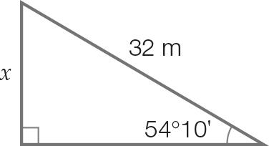

sin(54°10') = 

x = 32 × sin(54°10')

x = 25.9 m (1 d.p.)

Question 5 [6.3]

D

Length of shadow at 4 p.m. is 7.5 m.

Angle required:



Question 6 [6.3]

D

Need to calculate both angles.

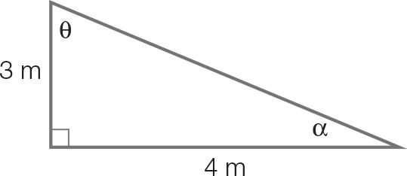

|  |  |
| --- | --- |
| tan(θ) = | tan(α) = |

The smaller angle is closest to 37°.

Question 7 [6.4] 6.4

D



Distance is 11 019 m (nearest metre)

Question 8 [6.5] 6.5

C

sin(θ) = 0.383

θ = sin-1(0.383)

θ = 22.5°

θ = 22°30'

The compass bearing is N22°30'E.

Question 9 [6.5] 6.5

B

315° − 270° = 45°

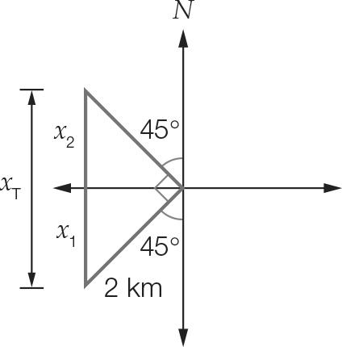

Calculate one of the lengths, x1 which is due north.

x1 = 2 × sin(45°)

x1 =1.41 km

x2 = 1.41 km

Total distance due north, xT = 2 × 1.41 = 2.82 km

Total distance is:

2 + 2 + 2.82 = 6.8 km (1 d.p)

Question 10 [6.6] 6.6

C

x = 56 × sin(36°22')

= 33.21

y = 

y = 71.05

Multiple-choice results: 10

Short answer section

Question 11 2 marks [6.2]

(a) h = 2.4 × sin(48°) = 1.78 m

(b) h = 1.2 × sin(48°) = 0.89 m

Question 12 4 marks [6.3]

(a) Let θ be the angle between the stairs and the ground.  
θ = tan-1   
θ = 55.71°  
θ = 55° 42' 36"

(b) Let the height of stairs be s.  
There are 9 vertical heights in the 8 steps, including the vertical distance of the eighth step, up to the top level.  
  
Distance between steps =   
= 0.3 m  
= 30 cm

Question 13 7 marks [6.2, 6.3, 6.5]

(a) Total length of fencing required  
=

  
The total length is 192 m (nearest m).

(b) Length of BD:  m

(c) 

(d) Angle between 70 m border and pipe is tan-1   
Bearing is 90° + 8.69° = 98.69°T  
= 98°41'24"  
or   
90° – 8°41'24" = S81°18'36"E

Question 14 7 marks [6.2, 6.3, 6.5]

(a) East: 48 sin(50°) = 36.77 km  
North: 48 cos(50°) = 30.85 km

(b) Distance:  km

(c) Angle required:  
  
Bearing is 064°31'48"T

Question 15 2 marks [6.6]

Let a be the angle the sloping face makes with the base.



Short answer results: ___ / 22

Extended answer section

Question 16 4 marks [6.2, 6.3]

(a) θ

(b) Let x be the distance AC.  
cos(66.42°) =   
x = 50 cos(66.42°)  
= 20.00  
The length of AC is 40 cm.

Question 17 5 marks [6.5]

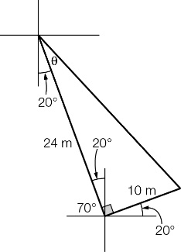

(a) What is the distance between the two hikers?  
 km

(b) θ =  
θ = 22°37'  
180° – 20° – 22°37’ = 137°23’  
Bearing is 137°T (nearest degree).

(c) Distance = 24sin(20°) + 10cos(20°)  
 = 11.78  
Bree is 12 km east of Alana.

Question 18 7 marks [6.6]

(a) Calculate θ:  
  
The angle is less than 77°, so the wires are safe.

(b) Using Pythagoras’ theorem:  
h =   
The height of the mast is 12 m.

(c) 77° – 53.13° = 23.87°  
The maximum angle is 23.87°.  
Let x be the length of the new wire.  
  
The maximum length of the new wire is 13.12 m, so the wire could be extended by 12 cm.

Extended answer results: 16

TOTAL test results: 48